CALL JAVAH and ndk-build.cmd

Tutorial how to access javah and ndk-build.cmd in Command prompt

Put your bin path to system variales like this

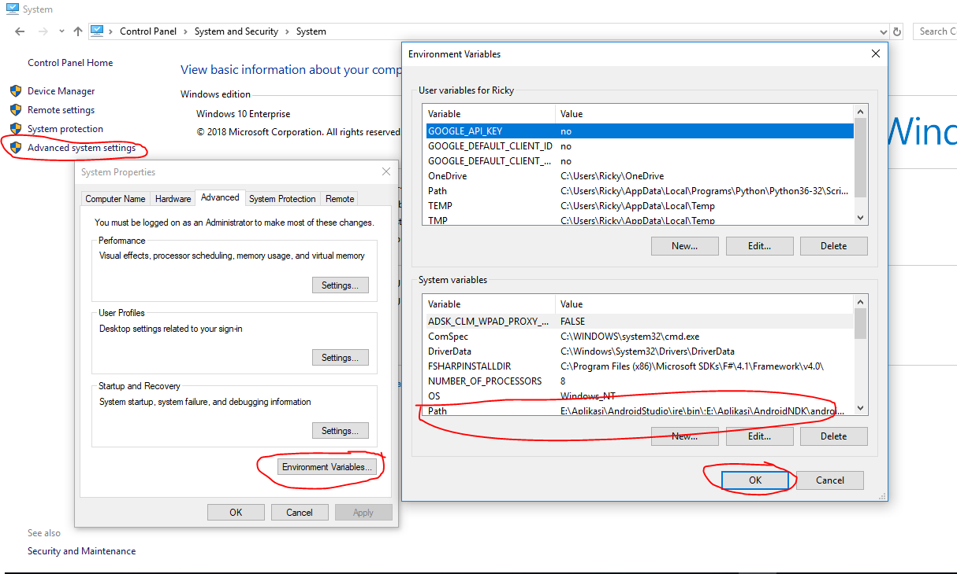

Then try open up your cmd

If it will come to like this picture, then you done, Congratulations

